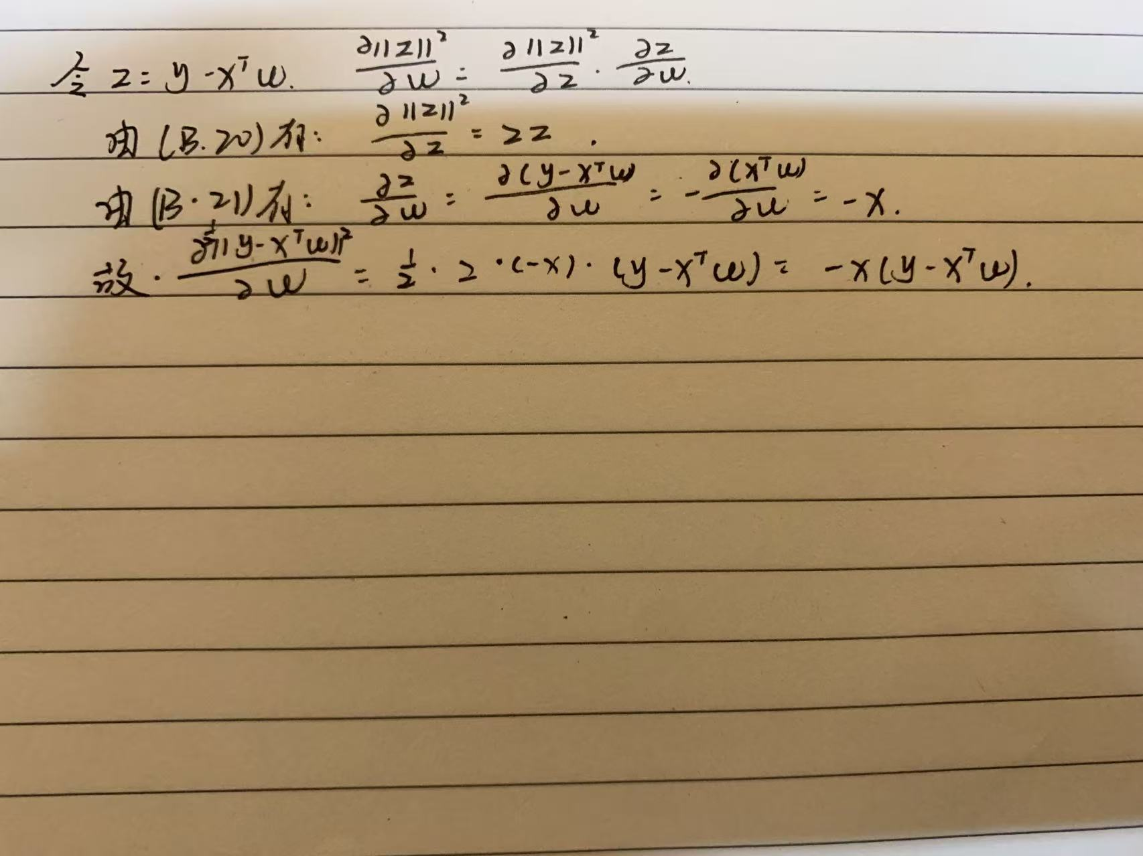
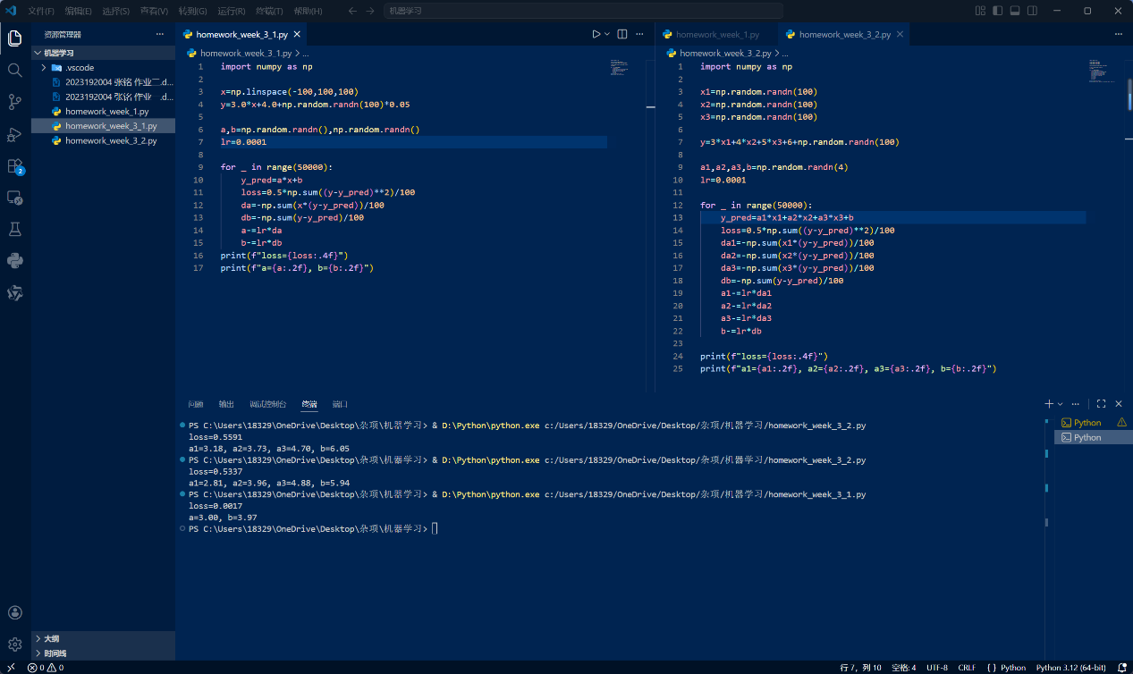

import numpy as np

x=np.linspace(-100,100,100)
y=3.0*x+4.0+np.random.randn(100)*0.05

a,b=np.random.randn(),np.random.randn()
lr=0.0001

for _ in range(50000):
y_pred=a*x+b
loss=0.5*np.sum((y-y_pred)**2)/100
da=-np.sum(x*(y-y_pred))/100
db=-np.sum(y-y_pred)/100
a-=lr*da
b-=lr*db
print(f"loss={loss:.4f}")
print(f"a={a:.2f}, b={b:.2f}")
import numpy as np

x1=np.random.randn(100)
x2=np.random.randn(100)
x3=np.random.randn(100)

y=3*x1+4*x2+5*x3+6+np.random.randn(100)

a1,a2,a3,b=np.random.randn(4)
lr=0.0001

for _ in range(50000):
y_pred=a1*x1+a2*x2+a3*x3+b
loss=0.5*np.sum((y-y_pred)**2)/100
da1=-np.sum(x1*(y-y_pred))/100
da2=-np.sum(x2*(y-y_pred))/100
da3=-np.sum(x3*(y-y_pred))/100
db=-np.sum(y-y_pred)/100
a1-=lr*da1
a2-=lr*da2
a3-=lr*da3
b-=lr*db

print(f"loss={loss:.4f}")
print(f"a1={a1:.2f}, a2={a2:.2f}, a3={a3:.2f}, b={b:.2f}")

